Mixing
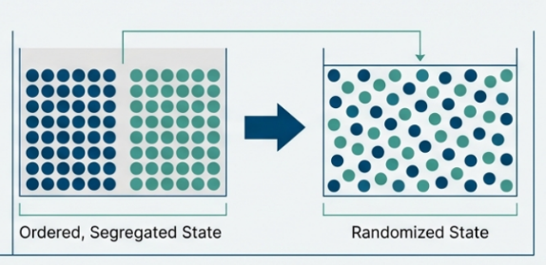
In simple terms, mixing is the process of taking two or more different ingredients and combining them so that they are spread evenly throughout the system such that each particle of any one ingredient is as nearly as possible adjacent to a particle of each of the other ingredients.
The ultimate goal is to achieve a randomization of dissimilar particles within a system, ensuring that small samples withdrawn from a bulk material accurately represent the overall composition.

Classification of Mixing Systems
The approach to mixing depends heavily on the physical properties of the materials, categorized into three types of mixtures:
- Positive Mixtures: These mix completely on their own without needing extra energy, like two gases or liquids that blend naturally.
- Negative Mixtures: These are difficult to keep mixed because the components tend to separate quickly (due to density differences), such as solids suspended in liquids or creams. They are difficult to form and maintain, requiring continuous energy input to prevent segregation.
- Neutral Mixtures: These are static; they don't mix on their own, but they also don't separate on their own once they are mixed. Common examples include powders, pastes, and ointments.
Equipment Used.
Different machines are used based on whether the material is a liquid, a thick paste (semisolid), or a dry powder:
- Liquid Mixers: Often use impellers (like propellers or paddles) or air jets to circulate the fluid.
- Semisolid Mixers: Use heavy-duty tools like kneaders (sigma-blades) or planetary mixers to handle thick, sticky masses.
- Solid Mixers: Often involve tumbling containers (like twin-shell or drum blenders) that rotate to move the powder in all directions.
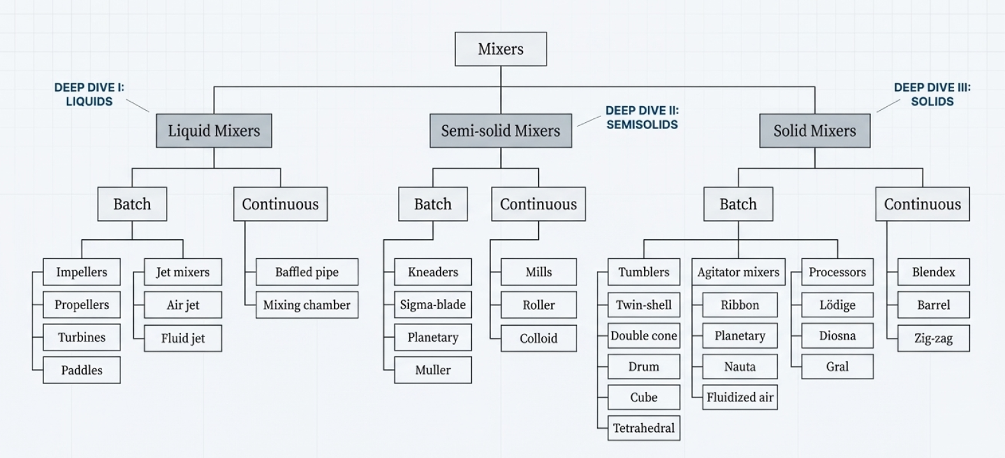
Mechanisms of Mixing
The science of mixing varies significantly between liquids and solids.
Liquid Mixing :
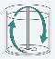
Liquid mixing generally involves four mechanisms often operating simultaneously:

- Bulk Transport: The movement of large portions of material from one location to another using paddles or blades to shuffle the system in three dimensions.

- Turbulent Mixing: Resulting from random velocity fluctuations, this mechanism produces eddies (fluid units moving in directions contrary to the general flow), which break into smaller sizes until they are indistinguishable.
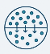
- Laminar Mixing: Used for highly viscous fluids, this involves stretching and folding fluid layers back upon themselves, which exponentially increases the interfacial area between dissimilar liquids.
- Molecular Diffusion: The primary mechanism for mixing at the molecular level, driven by thermal motion and described by Fick’s first law.
Solid (Powder) Mixing:
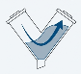
Solid mixing is considered a "chance" process where the best outcome is usually a "random mix" rather than a "perfect mix". The mechanisms include:
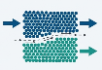
- Convective Mixing: Analogous to bulk transport, where large masses of material are moved by blades, paddles, or screws.
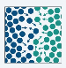
- Shear Mixing: Occurs when slip planes are set up within the particulate mass, reducing the scale of segregation by thinning dissimilar layers.
- Diffusive Mixing: Involves the random motion of individual particles within a powder bed, causing them to change positions relative to one another.
Challenges:
Segregation (percolation segregation)
The central problem in solid mixing is segregation (demixing), where particles separate due to differences in size, density, shape, or charge. Particle size is the primary cause, as smaller particles tend to fall through voids between larger particles—a process known as percolation segregation.
Ordered Mixing
Conversely, ordered mixing is a beneficial technique used for potent drugs. In this process, a drug in a fine powder state is made to coat carrier particles uniformly. This creates a stable mixture that resists separation and is highly effective for formulations where the active ingredient is present in very low percentages.
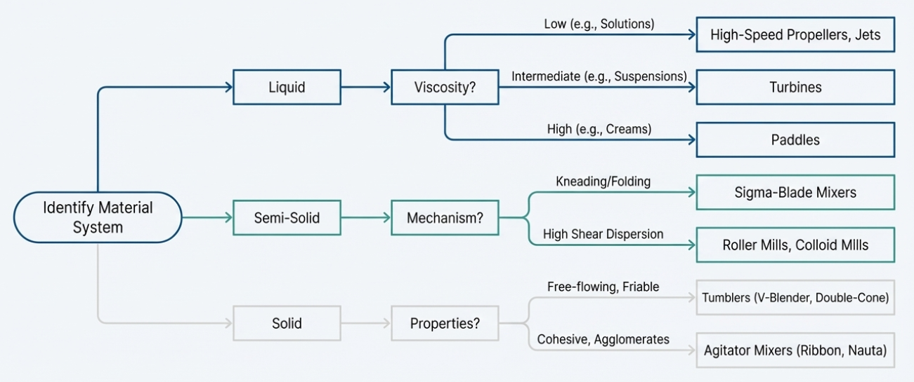
Evaluation and Practical Considerations
The quality of a mixture is judged by the "goodness of mixing," measured through the scale of segregation (the average diameter of unmixed "lumps") and the intensity of segregation (the variation in composition among portions of the mixture). In practice, mixing can be complicated by vortexing in liquids—an undesirable centrifugal effect that draws air into the impeller and causes foaming. This is typically managed by using baffles or off-center impeller mounting to destroy symmetry and induce turbulence.
Liquid Mixing:
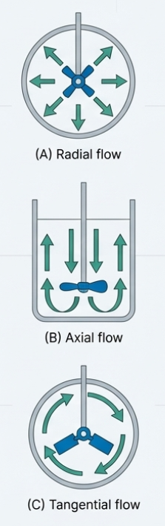
Liquid mixing is primarily designed to provide a means of supplying energy to a fluid mass to bring about rapid mixing. A system generally consists of a tank or container to hold the material and a power source, such as an impeller, air stream, or liquid jet. The choice of equipment is largely determined by the viscosity of the liquid and the desired flow pattern.
1. Batch Mixing:
Impellers:
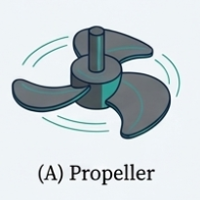
Impellers are the most common tools for mixing liquids in tanks. They are classified by their shape, pitch, and the flow patterns they produce—axial (parallel to the shaft), radial (perpendicular to the shaft), or tangential (circular around the shaft).
1. Propellers:
- Introduction: These are high-speed impellers used primarily for thin liquids.
- Mechanism: They operate through turbulent flow, projecting "eddies" (small units of fluid) into the surrounding liquid to prevent "dead zones" where no mixing occurs.
- Construction: They are shaped like a multithreaded screw. The most common design has three blades, where the distance the liquid moves per revolution (pitch) is roughly equal to the propeller's diameter.
- Working: They run at high speeds (up to 8,000 rpm) and produce axial flow, meaning the liquid moves in a direction parallel to the impeller shaft.
- Limitation: They are limited to low-viscosity liquids (less than 5 poise). A major problem is vortexing, where a whirlpool forms, and drawing air into the mixture.
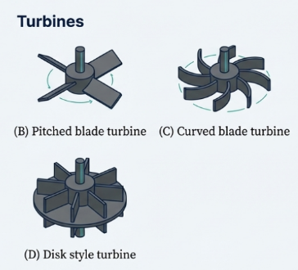
- Overcoming Limitations: Vortexing is avoided by mounting the propeller off-center, using baffles on the tank walls, or using push-pull propellers (two propellers with opposite pitches on one shaft).
- Advantages: They are highly efficient at high speeds and effective at circulating the entire mass of low-viscosity material.
- Pharmaceutical Applications: Used for making simple solutions and elixirs.
2. Turbines:
- Introduction: Turbines are rugged impellers used for liquids that are more viscous than those handled by propellers.
- Mechanism: They use centrifugal action to move the liquid.
- Construction: They consist of blades typically set at a 90-degree angle to the shaft. They are often fitted with "stators" (stationary rings) to increase shearing action.
- Working: They operate at medium speeds (50–200 rpm) and produce radial flow (liquid moves perpendicular to the shaft).
- Limitation: They can still create a vortex at high speeds, and they have a lower pumping capacity than propellers of the same size.
- Overcoming Limitations: Using vertical side-wall baffles or diffuser rings around the impeller can eliminate the vortex and increase turbulence.
- Advantages: They can handle fluids 1,000 times more viscous than propellers. Their power consumption is also relatively unaffected by the density or viscosity of the material.
- Pharmaceutical Applications: Primarily used for preparing emulsions and suspensions.
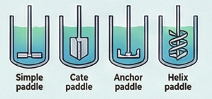
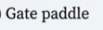
3. Paddles:
- Introduction: Paddles are impellers designed for high-viscosity systems.
- Mechanism: They mix by shoving or shuffling the material in three dimensions.
- Construction: They feature blades with a large surface area relative to the tank. Common types include gate, anchor, and helix paddles.
- Working: They operate at very low speeds (usually less than 100 rpm). The blades pass very close to the tank walls to prevent thick material from sticking.
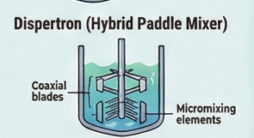
- Limitation: They produce tangential flow, which can lead to "stratification" (layers of different materials that don't mix).
- Overcoming Limitations: Prolonged mixing times or the use of hybrid mixers (like the "Dispertron") with counter-rotating blades can improve the result.
- Advantages: They generate maximum shear with minimal air entrapment and almost no vortex formation.
- Pharmaceutical Applications: Used for thick materials like gels, pastes, and ointments.
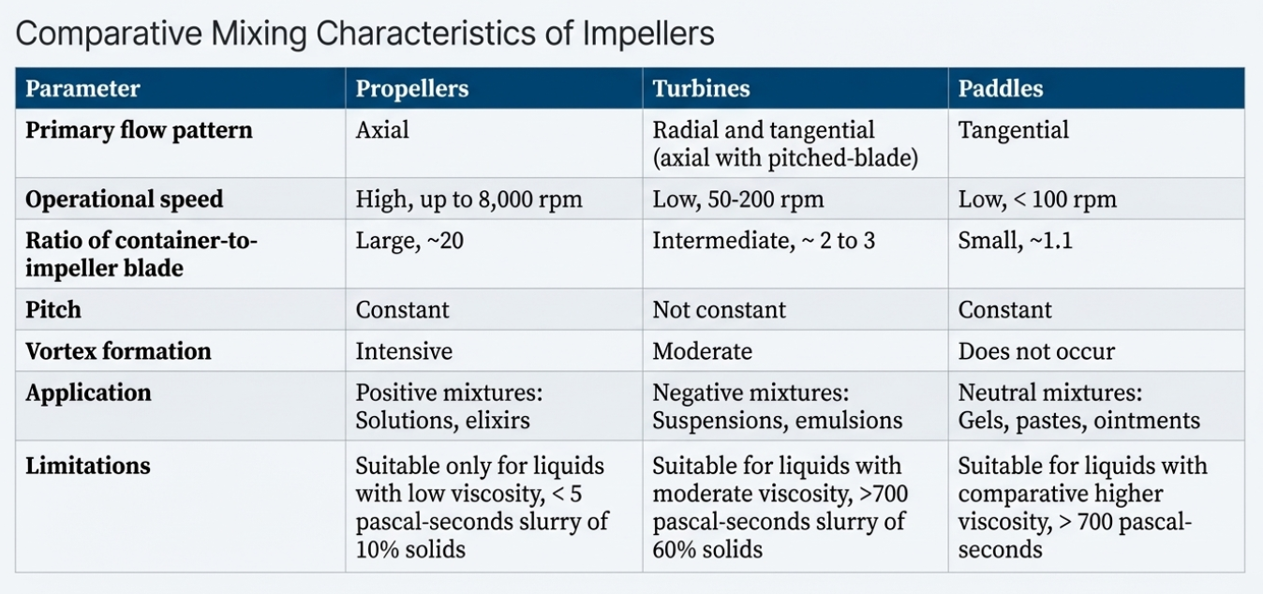
Ancillary Equipment and Practical Modifications
- Baffles: Vertical plates attached to the tank walls are used to convert tangential flow into axial flow. This prevents vortexing (the undesirable swirling that entrap air and reduces mixing power). Baffles allow for a significant increase in the power that can be efficiently applied by the impeller.
- Impeller Placement: To avoid vortexing without using baffles (which can be hard to clean), impellers are often mounted in off-center, inclined, or side-entering positions to destroy the symmetry of the mixer.
- Push-pull Propellers: These feature two propellers of opposite pitch on the same shaft; their opposing rotations cancel out swirling effects to prevent vortexing.
Jet Mixers
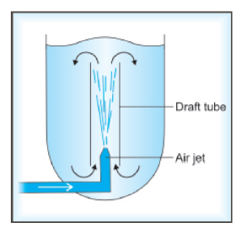
1. Air Jets:
- Introduction: These are batch mixers that use compressed gas instead of mechanical blades.
- Mechanism: Mixing is achieved through buoyancy, where air bubbles lift the liquid.
- Construction: A nozzle is placed at the bottom of a tank, often inside a draft tube to confine the bubbles.
- Working: Subsurface jets of air release bubbles that lift liquid from the bottom to the top, creating a circulation loop that brings all parts of the liquid into a region of intense turbulence.
- Limitation: Only suitable for low-viscosity, non-foaming, and nonreactive liquids.
- Overcoming Limitations: Draft tubes are used to ensure the lifting action is efficient and the circulation is directed properly.
- Advantages: There are no moving parts inside the tank, making it useful for certain specialized liquids.
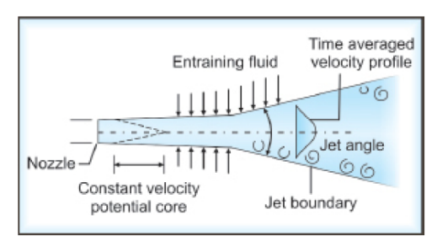
- Pharmaceutical Applications: Used for low-viscosity monophasic systems.
2. Fluid Jets:
- Introduction: These mixers use the power of high-pressure liquid streams to stir a tank.
- Mechanism: They operate through entrainment, where the high-pressure stream pulls surrounding stationary liquid into the flow.
- Construction: They consist of nozzles arranged to permit circulation throughout the tank.
- Working: Liquid is pumped at high pressure through the nozzles, creating a turbulent flow pattern similar to a propeller (axial flow).
- Limitation: They do not generate tangential flow on their own.
- Overcoming Limitations: Proper arrangement of the nozzles is required to ensure the entire volume of the tank is circulated.
- Advantages: Mixing can be accomplished simply by pumping the liquid from the tank and back into it, requiring little extra equipment.
- Pharmaceutical Applications: Suitable for low-viscosity liquids in large tanks.
Continuous (In-line) Mixers:
- Introduction: These are used when a large, uninterrupted supply of mixed material is needed.
- Mechanism: Mixing occurs through mass transport in a direction normal to the primary flow.
- Construction: They usually consist of a pipe or tube containing stationary vanes, baffles, or screws.
- Working: Ingredients are fed into the pipe. As they move through, the internal baffles create turbulence and recirculation, causing the materials to blend by the time they reach the exit.
- Limitation: They lack the high degree of recirculation found in tanks, meaning any error in the feed rate of raw materials results in an uneven mixture.
- Overcoming Limitations: Precise metering devices for the raw materials are required to maintain a uniform composition.
- Advantages: Very efficient for very large volumes; they require very little power beyond what is needed to move the fluid through the pipe.
- Pharmaceutical Applications: Used for high-volume liquid manufacturing where composition uniformity is critical.
- Baffled Pipe Mixers: These are tubes containing fixed internal elements like vanes, baffles, screws, or grids that shuffle the material in a direction normal to the primary flow.
- Mixing Chambers: These provide a section in the flow line with considerable holdup and recirculation to ensure uniform composition.
- Tanks in Series: Using multiple stirred tanks in a sequence is more effective at reducing composition fluctuations than a single large tank, a phenomenon known as the serial dilution effect.
Semisolid Mixing:
Semisolid mixing involves processing materials that lack the free-flowing characteristics of liquids or solids, such as pastes, ointments, and creams. Because these materials are highly viscous and cohesive, their mixing requires specialized equipment designed for heavy-duty performance to induce the necessary shear, kneading, and folding actions.
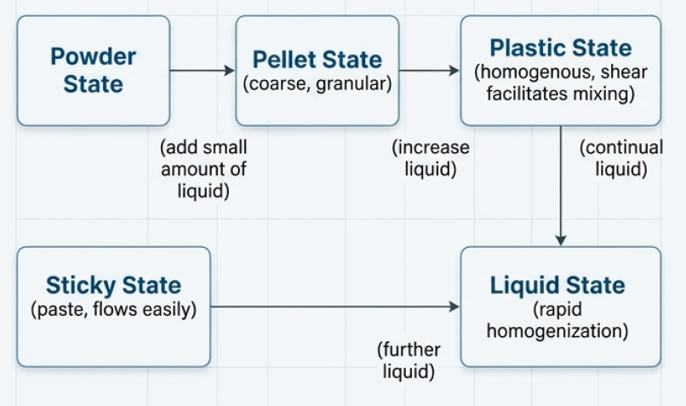
Mixing semisolids (like creams, ointments or pastes) is unique because the material changes its physical state as you add liquid:
- Powder State: Initially resembles dry powder mixing.
- Pellet State: The powder "balls up" as liquid is added.
- Plastic State: The mixture becomes uniform but is very thick and hard to move.
- Sticky State: Becomes a paste that flows easily but is slow to homogenize.
- Liquid State: Finally behaves like a fluid.
Equipment for semi-solid mixing:
Semisolid mixing equipment is broadly classified into batch mixers (kneaders and mullers) and continuous mixers (mills).
Kneaders (Batch Mixers)
Kneaders are designed to handle thick, plastic masses by applying intense mechanical force.
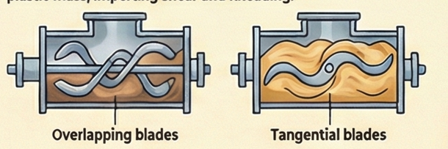
1. Sigma-Blade Mixer (Kneader):
- Introduction: This is a heavy-duty batch mixer specifically designed to handle thick, plastic masses.
- Mechanism: It works through kneading and pulling. The blades perform a lateral pulling action that stretches and folds the material.
- Construction: It consists of two counter-rotating blades or heavy arms. These blades rotate tangentially at a speed ratio of approximately 2:1.
- Working: As the blades turn at different speeds, they draw the thick material into the center and subject it to high shear forces. This shear is generated by the high viscosity of the mass itself, which helps break apart clumps of solids.
- Limitation: It has high power requirements and is difficult to clean compared to simpler mixers like tumblers.
- How to Overcome: Robust construction is essential to handle the stress of the thick mass.
- Advantages: It is highly effective at deaggregating (breaking down) solids and distributing them into a fluid vehicle.
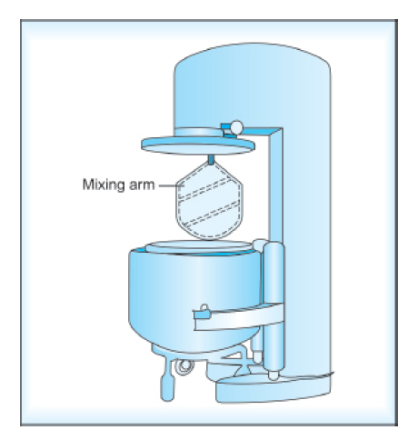
- Pharmaceutical Applications: Used for high-viscosity masses, such as doughs, pastes, and thick ointments.
2. Planetary Mixer:
- Introduction: A versatile batch mixer where the mixing element moves like a planet, traveling around the container while also spinning on its own axis.
- Mechanism: It provides a double rotation action that ensures the mixing blade reaches every part of the container.
- Construction: It consists of a mixing arm and a stationary container. The mixing element is often offset from the center.
- Working: The blade rotates on its own shaft while simultaneously revolving around the circumference of the mixing vessel. This combined motion moves the material throughout the entire bowl.
- Limitation: Like the sigma-blade mixer, it requires high power to operate when handling thick materials.
- Advantages: The double rotation significantly reduces "dead zones" (areas where material doesn't move) and prevents the formation of a vortex.
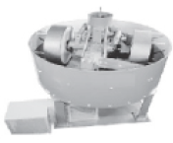
- Pharmaceutical Applications: Commonly used for wet massing (mixing powders with liquids to make granules) and processing ointments.
Muller Mixer (Mulling Mixer – Batch Mixer):
- Introduction: This mixer is an extension of the kneading process, designed to provide intensified work forces for a uniform consistency.
- Mechanism: It uses kneading, shearing, and smearing. It applies enough pressure to move and intermingle particles without crushing or grinding them.
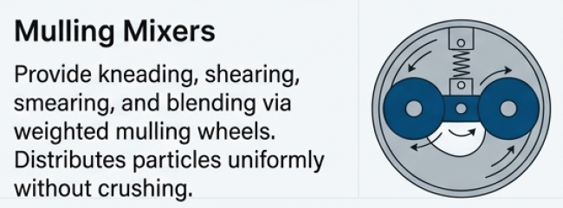
- Construction: It features heavy, weighted mulling wheels mounted on a spring suspension arrangement. This allows the user to adjust the amount of pressure (work) applied to the mixture.
- Working: The material is moved under the tread of the wheels. The wheels "smear" the material, which helps break down aggregates of solid particles.
- Limitation: It is typically inefficient at initially distributing particles uniformly throughout the mass.
- How to Overcome: It should be used for material that has already been roughly mixed into a uniform composition. If the material separates (segregation) during mulling, a final remixing stage may be needed.
- Advantages: It provides a final mixture of truly uniform physical and chemical structure by deaggregating solid clumps.
- Pharmaceutical Applications: Used for mixing materials that contain aggregates of solid particles that need to be smoothed out into a paste.
Roller Mills (Continuous Mixers):
- Introduction: These are continuous mixers used to smooth out semisolid mixtures and ensure solid particles are perfectly coated with liquid.
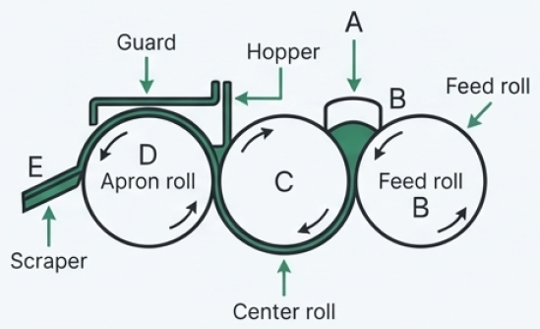
- Mechanism: They operate through crushing and high shear. The shear is created by the different rotation speeds of the rollers.
- Construction: Usually, three rollers made of hard, abrasion-resistant material are used. A scraper is positioned at the end to remove the finished material.
- Working: Material passes between the rollers. The gap between each subsequent roller is smaller, and the rollers rotate at different speeds. This difference in speed shears the material, reducing the size of any remaining lumps and smoothing the mixture.
- Limitation: In extreme cases of solid-liquid mixing, particles can form large lumps.
- How to Overcome: The liquid should be added slowly to reduce the tendency of particles to form lumps.
- Advantages: It provides a very high degree of smoothing and ensures that even small volumes of liquid are evenly spread over large quantities of solids.
- Pharmaceutical Applications: Used to process pastes and ointments to achieve a smooth, grit-free texture.
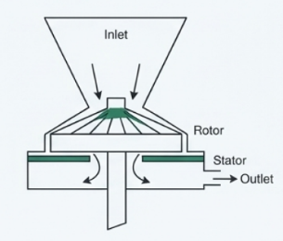
Colloid Mill (Continuous Mixers):
- Introduction: A high-speed mixer used to process semisolids and create very fine emulsions or suspensions.
- Mechanism: It utilizes centrifugal force and hydraulic shear. Centrifugal force throws the material across the rotor and onto the stator, where intense shear occurs in the tiny gap between them.
- Construction: It consists of a high-speed rotor (3,000 to 20,000 rpm) and a stationary stator. The gap between them is adjustable, ranging from 0.002 to 0.03 inches.
- Working: Material is fed into the center and thrown outward by the rotor. The hydraulic shear in the narrow gap breaks down particles to as small as 3 micrometers.
- Limitation: Smooth-surfaced mills can be clogged by fibrous materials that interlock.
- How to Overcome: Use rough-surfaced rotors and stators to add turbulence and prevent clogging. Additionally, materials should be pre-milled as finely as possible before being put into the colloid mill to prevent damage to the equipment.
- Advantages: It is capable of producing extremely fine dispersions and is very efficient for materials that have already been pre-mixed.
- Pharmaceutical Applications: Specifically used for emulsification, homogenization, and processing semisolids like stable creams and fine suspensions.
Practical Considerations for Selection
Because the forces required to mix thick pastes are considerable, these machines must be of a heavy, robust design. While these mixers are effective, they generally have higher power requirements and generate more mechanical heat than liquid or solid mixers. Furthermore, certain designs like the sigma-blade and planetary mixers can be more difficult to clean and may require more maintenance than simpler tumbling mixers.

Solid Mixing:
Solid mixing is a critical pharmaceutical process used to achieve a "random mix," where the probability of finding a specific type of particle at any point in the mixture is equal to its proportion in the total blend. This is often achieved through three main mechanisms: convective mixing (bulk movement of large masses), shear mixing (slip planes within the mass), and diffusive mixing (random motion of individual particles).
- Convective Mixing: Analogous to bulk transport, where large masses of material are moved by blades, paddles, or screws.
- Shear Mixing: Occurs when slip planes are set up within the particulate mass, reducing the scale of segregation by thinning dissimilar layers.
- Diffusive Mixing: Involves the random motion of individual particles within a powder bed, causing them to change positions relative to one another.
Below is a detailed discussion of solid mixing equipment.
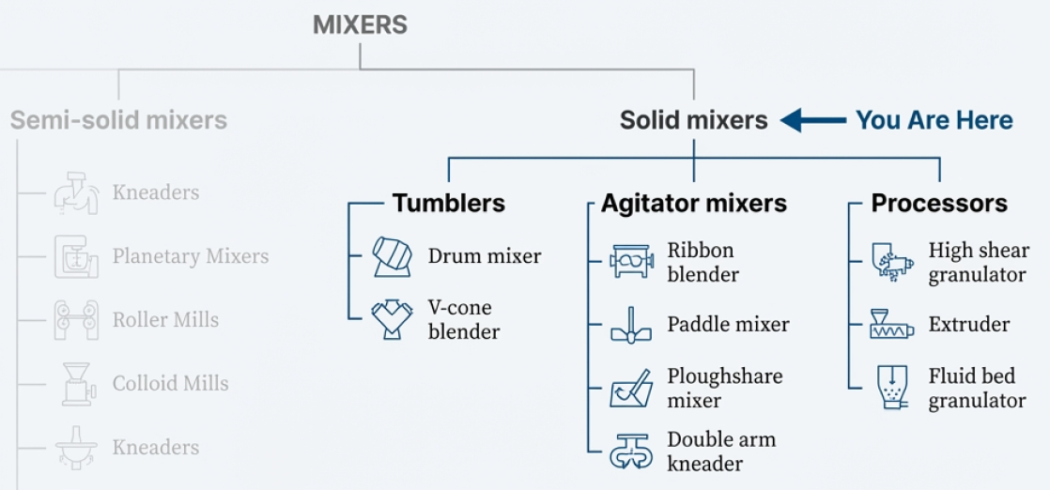
Tumbling Mixers
Tumbling mixers consist of a container in various geometric forms that rotate around an axis. They use mild forces, making them suitable for friable materials that might be damaged by more aggressive mixing. Their efficiency is highly dependent on rotation speed: too slow a speed fails to produce the necessary "avalanching" motion, while too fast a speed creates centrifugal forces that hold the powder against the walls. The optimum speed typically ranges from 30 to 100 rpm.
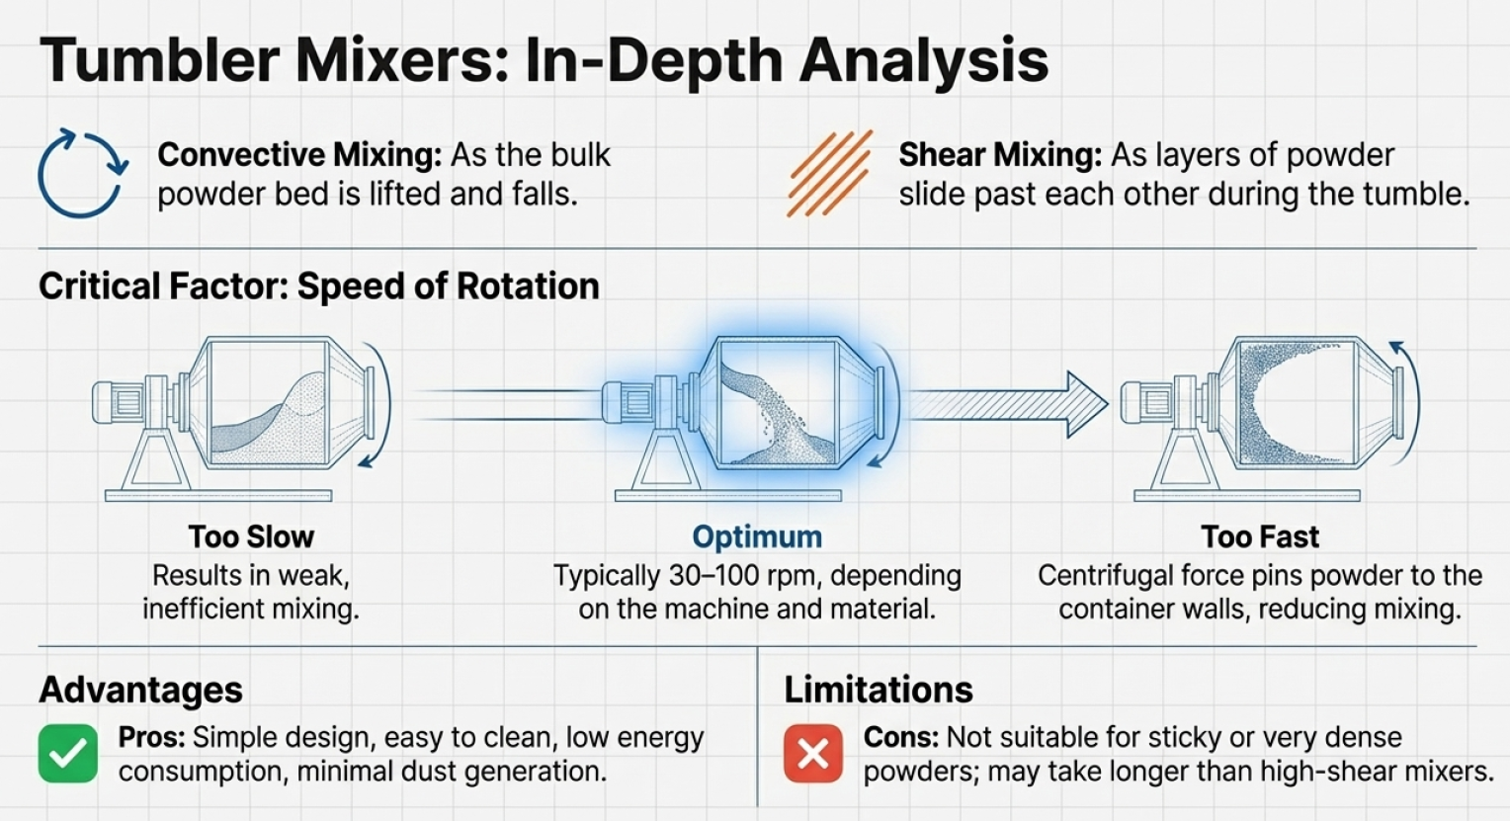
1. Twin-Shell Blender (V-Blender)
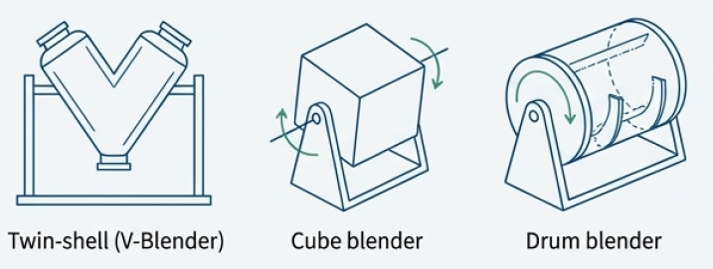
- Introduction: A popular tumbling mixer used for the precision blending of dry powders.
- Mechanism: It utilizes convective and shear mixing created by the tumbling action.
- Construction: It consists of two cylinders joined at a 45-degree angle to form a "V" shape. It may include an internal bar with blades (intensifier bar) for extra agitation.
- Working: As the V-shell rotates, the material is collected at the bottom of the "V" and then split into two portions when the shell is inverted.
- Limitation: It can suffer from poor cross-flow along the axis and may cause segregation if powders are not similar in size and density.
- How to Overcome: The asymmetrical "V" design itself helps accentuate movement, and the use of internal blades can improve the agitation of the powder bed.
- Advantages: It provides a mild mixing force suitable for friable (fragile) materials and is highly efficient for precision blending.
- Pharmaceutical Applications: Used for dry powder blending and is often a step prior to the introduction of liquids.
- Double-cone Blender: This design provides a good cross-flow through a rolling pattern, which is more efficient for mixing than the "sliding" motion found in cube or tetrahedral blenders.
- Cube and Tetrahedral Blenders: These use flat surfaces that subject the powder to sliding rather than rolling. While useful, they are generally less conductive to efficient mixing than the twin-shell or double-cone designs.
- Intensifier Bars: Many tumblers can be fitted with a bar containing blades that rotate in the opposite direction of the shell to break up clumps or a hollow tube to inject liquids into the powder.
Agitator Mixers:
Agitator mixers utilize a stationary container and moving internal parts like screws, blades, or paddles. These are particularly useful for solids that have been wetted or are in a sticky or plastic state, as they generate the high shear forces needed to break up lumps.
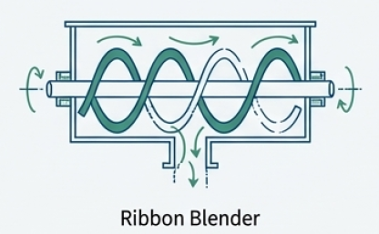
1. Ribbon Mixer/Blender
- Introduction: An agitator mixer consisting of a stationary container with moving internal parts.
- Mechanism: It works through convective mixing, using helical blades to circulate the material.
- Construction: A horizontal cylindrical tank fitted with helical ribbons mounted on a central axle. The ribbons are wound in opposite directions.
- Working: The ribbons rotate to move the material in both directions along the axis of the tank simultaneously.
- Limitation: It is difficult to clean as compared to tumblers and has high power requirements. It also has low axial mixing in the area immediately around the shaft.
- How to Overcome: Homogeneity can still be achieved by allowing for prolonged mixing times, even if particles differ in size or density.
- Advantages: The high shear forces generated are highly effective at breaking up lumps or aggregates.
- Pharmaceutical Applications: Suitable for mixing solids that have been wetted or are in a sticky, plastic state.
2. Nauta Mixer
- Introduction: A vertical screw mixer that provides three-dimensional mixing.
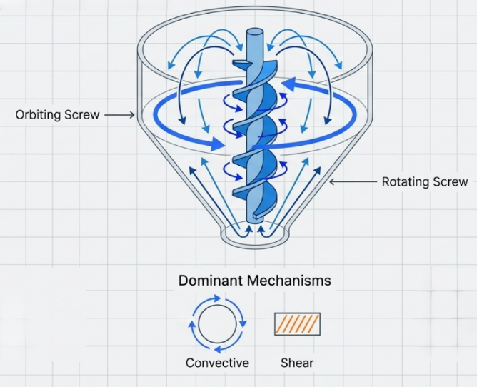
- Mechanism: It utilizes convective mixing by lifting and circulating the powder bed.
- Construction: A conical chamber containing a screw assembly that both rotates and orbits.
- Working: The screw rotates on its own axis while orbiting the wall of the conical chamber, lifting powder from the bottom to the top.
- Limitation: High power requirements are common for agitator-type mixers.
- How to Overcome: It can be fitted with a lump breaker at the bottom or constructed for vacuum drying to handle specific material needs.
- Advantages: It requires very little floor space and keeps the material in constant motion.
- Pharmaceutical Applications: Used for powder and semisolid mixing, wet massing, and drying materials using hot air.
- Planetary Mixer: The mixing element rotates around the circumference of the container while also rotating on its own axis. This dual rotation prevents "dead zones" where material might sit still.
- Fluidized Air Mixer: Instead of a mechanical impeller, this mixer uses a rapidly moving stream of air fed into the bottom of the shell to fluidize the powder bed, mixing through circulation and over-tumbling.
High-Speed Processors (Rapid Mixer-Granulators)
These newer machines are designed to perform both dry mixing and wet granulation rapidly within the same unit, often completing a mix in 30 to 60 seconds.
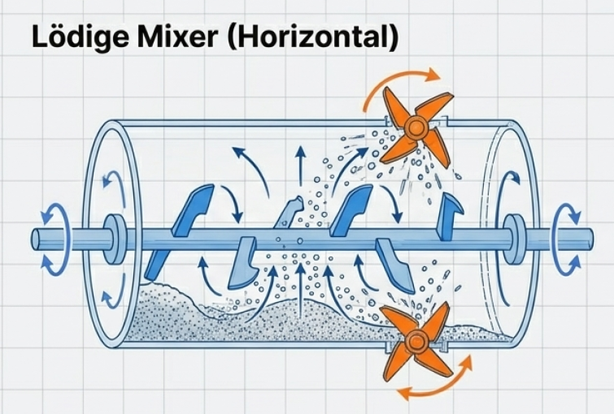
1. Lödige Mixer (Rapid Mixer-Granulator)
- Introduction: One of the first high-shear powder blenders used in the industry.
- Mechanism: It combines impact and shear to blend materials.
- Construction: A horizontal cylindrical shell equipped with plow-shaped mixing tools and high-speed chopper blades.
- Working: The plow-shaped tools revolve to keep the material in a fluidized condition, while the high-speed choppers disperse dry lumps.
- Limitation: The high-shear action can damage sensitive particles if not monitored.
- How to Overcome: The mixing tools can be revolved at variable speeds to maintain the desired intensity without damaging the product.
- Advantages: It is extremely fast, achieving complete mixing in as little as 30 to 60 seconds.
- Pharmaceutical Applications: Used for rapid blending of powders and wet massing within the same equipment.
2. Diosna Mixer-Granulator
- Introduction: A high-speed vertical powder mixer and processor.
- Mechanism: It achieves mixing through intensive shear and impact.
- Construction: A vertical bowl containing a high-speed mixer blade at the bottom and a separate high-speed chopper.
- Working: The bottom blade revolves to move the mass while the chopper functions as a lump and agglomerate breaker.
- Limitation: Like all agitators, it can be energy-intensive and may cause abrasion of particles.
- How to Overcome: The intense shear is necessary to fragment agglomerates in cohesive materials (fine particles <100 µm) where simple tumbling is ineffective.
- Advantages: Very effective for processing materials that exhibit high forces of cohesion.
- Pharmaceutical Applications: Used for rapid mixing and granulation in tablet and capsule manufacturing.
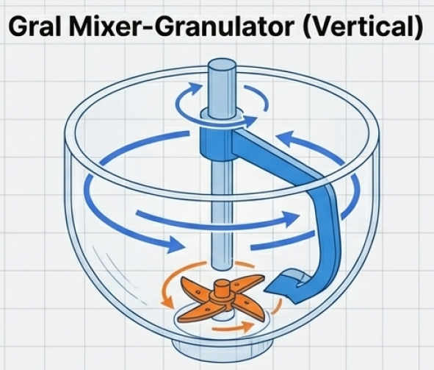
3. Gral Mixer-Granulator
- Introduction: A specialized modification of the industrial planetary mixer.
- Mechanism: It uses a combination of mass motion and high-speed chopping.
- Construction: It features a rounded bowl with a large mixing arm and a secondary, off-center chopper blade.
- Working: The large arm provides wide-scale motion to the powder, while the chopper provides high-shear dispersion.
- Limitation: Traditional planetary mixers are difficult to clean.
- How to Overcome: In the Gral unit, the main mixing blade is not part of the bowl, which makes the clean-up process much easier.
- Advantages: It offers the high-shear benefits of the Lödige and Diosna units but with improved maintenance features.
- Pharmaceutical Applications: Used for large-scale industrial powder mixing and granulation.
Continuous Mixers
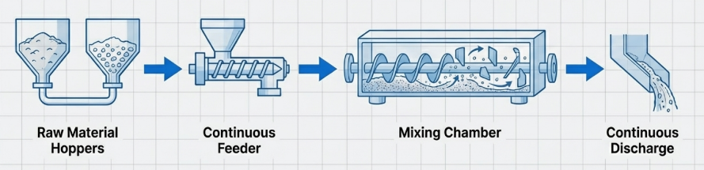
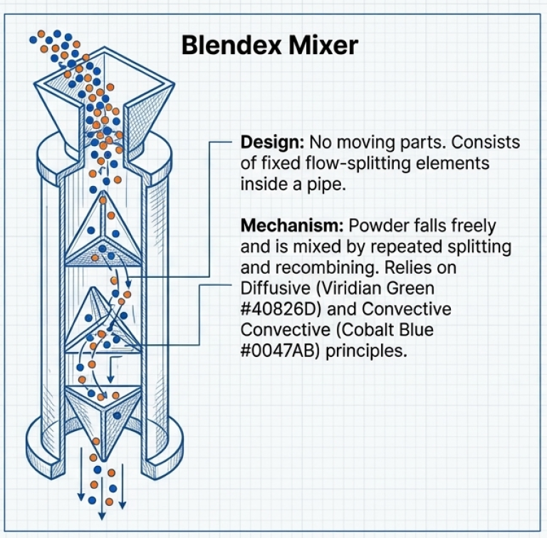
Continuous mixers provide an uninterrupted supply of mixed material and are preferred for very large-scale operations.
1. Blendex (Continuous Mixer)
- Introduction: An in-line continuous processing device that has no moving parts.
- Mechanism: It works through interfacial surface generation, splitting and twisting the flow of material.
- Construction: It consists of a series of fixed, flow-splitting elements and tetrahedral chambers arranged in a vertical plane.
- Working: Powders fall freely through the device and are mixed as they are split and twisted by the stationary internal elements.
- Limitation: The quality of the mix depends entirely on the number of chambers used.
- How to Overcome: The number of interconnected chambers can be adjusted based on the specific blending requirements of the solids.
- Advantages: It mixes without heat generation or particle size reduction and is highly efficient for large quantities (up to 5000 lb/hour).
- Pharmaceutical Applications: Used for the continuous blending of free-flowing solids.
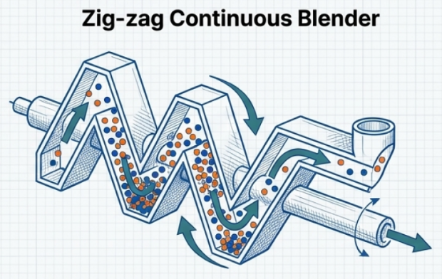
2. Zig-zag Continuous Blender
- Introduction: A continuous-flow version of the V-blender designed for large-scale production.
- Mechanism: It operates through a tumbling motion.
- Construction: It consists of several V-shaped blenders connected in a series.
- Working: As the blender rotates, half of the material moves backward while the other half moves forward; with each rotation, a portion moves toward the discharge end.
- Limitation: It is susceptible to composition variations if the input rate of raw materials fluctuates.
- How to Overcome: It requires the use of precise metering devices to ensure an exact and uniform feed of powders or granules.
- Advantages: It provides high composition uniformity while significantly reducing the effective volume needed compared to batch blenders.
- Pharmaceutical Applications: Essential for high-volume production of tablets and capsules where composition uniformity is critical.
- Barrel Type Mixer: Uses a tumbling motion combined with internal baffles. When material hits the midpoint of the shell, baffles force some of it to move backward, creating an intense mixing effect.
Segregation (Demixing)
A major problem in mixing is segregation (or demixing), where ingredients that were once mixed begin to separate. This often happens with powders if the particles have different sizes, densities, or shapes. For example, smaller particles tend to fall through the gaps between larger particles, causing them to collect at the bottom of a container.
Solids tend to segregate due to differences in particle properties:
- Particle Size: This is the most common cause of segregation. Smaller particles fall through voids between larger ones (percolation segregation), while larger particles may move greater distances during mixing due to higher kinetic energy (trajectory segregation).
- Particle Density: Denser particles tend to move downward even if sizes are similar.
- Particle Shape: Spherical particles exhibit the greatest flowability and are easily mixed but also segregate most easily.
- Particle Charge: Surface charges can cause particles to clump, which decreases the effectiveness of diffusive mixing.
Evaluation and Measures of Mixing
To judge the quality of a mixture, scientists use statistical criteria:
- Scale and Intensity of Segregation: The "scale" refers to the average diameter or volume of unmixed "lumps," while "intensity" measures the variation in composition among various portions of the mixture.
- Scale of Scrutiny: This is the smallest region that can measure imperfections in a mix. Its size depends on the final use; for example, in a tablet, the scale of scrutiny is the weight of a single tablet.
- Statistical Distribution: For a binary mixture of equal-sized particles, the expected variation is predicted using the binomial distribution. As the number of particles in a sample increases, the percentage variation in composition decreases.
Scale-Up Theory
Scaling a mixing process from a lab to a production plant involves using dimensionless groups to ensure similarity in fluid dynamics:
- Reynolds Number (Re): Indicates the ratio between inertial forces and viscous forces; high $R_e$ indicates turbulent flow, while low Re indicates laminar flow.
- Froude Number (Fr): Taken into account for powder systems where gravitational effects occur.
- Power Number (Pn): Relates the power dissipated in a mixer to the forces producing flow. In a fully baffled tank with turbulent flow, the power input is independent of viscosity but depends linearly on the density of the fluid.
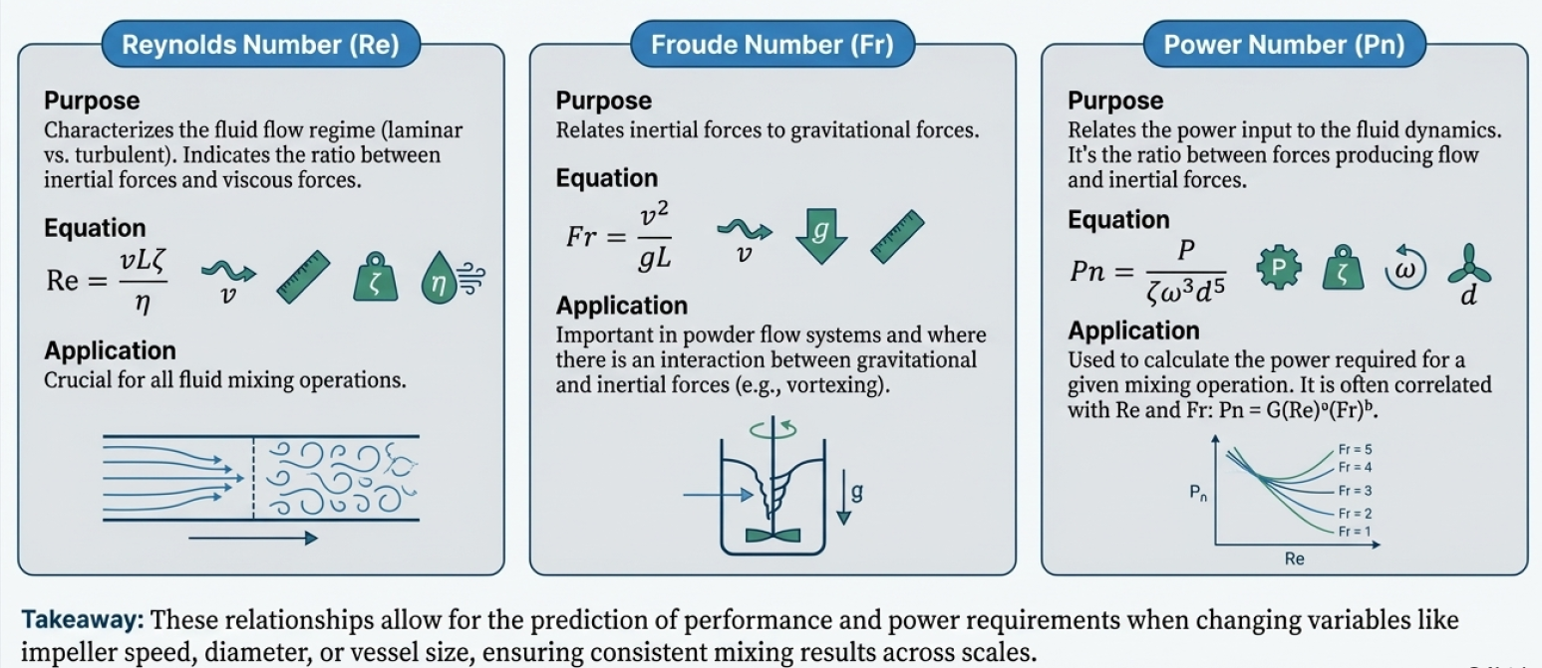
Vortexing
Vortexing is a phenomenon that occurs at the center of a mixing vessel when liquids are stirred by a centrally mounted, vertical-shaft impeller. It is particularly common when using turbines with blades arranged perpendicular to the shaft, as these induce a tangential flow (swirling) that does not contribute much to actual mixing.
Why Vortexing is Problematic
Vortexing creates several undesirable effects in the pharmaceutical manufacturing process:
- Air Entrapment and Foaming: As a vortex forms, air is drawn down into the impeller and dispersed into the liquid, which can lead to excessive foaming, especially if surfactants are present.
- Chemical Degradation: The entrapped air can cause the oxidation of sensitive substances.
- Reduced Efficiency: Vortexing reduces mixing intensity because the velocity of the impeller relative to the surrounding fluid is lowered, meaning the full power of the impeller is not actually transferred to the liquid.
- Scale-up Difficulties: It makes it nearly impossible to accurately scale up a process from a small lab to a large production plant because it disrupts the geometric and kinematic similarities between different vessel sizes.
How Baffles Prevent Vortexing
Baffles (or baffle plates) are auxiliary devices used to eliminate excessive swirl. They are essentially plates or obstructions attached to the mixing tank that break up the circular flow.
- Flow Conversion: Baffles work by converting tangential flow into axial flow. Instead of the liquid simply swirling around the center in a circle, the baffles force the liquid to move up and down (vertically), ensuring it passes through the high-turbulence zones near the impeller.
- Increased Turbulence: By breaking the steady swirl, baffles induce turbulence in their immediate proximity, which significantly aids the overall mixing process.
- Power Application: The use of baffles allows for a significant increase in the amount of power that can be efficiently applied by the impeller to the liquid mass.
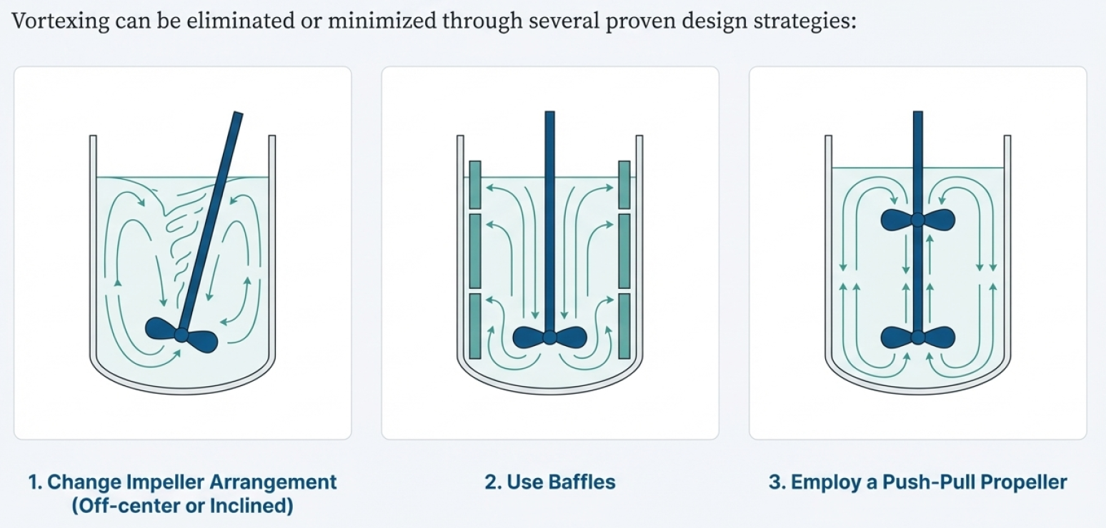
Practical Implementation of Baffles
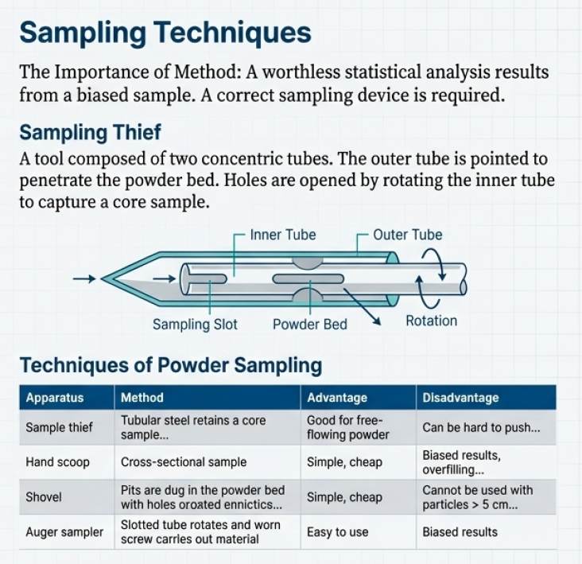
In practice, side-wall baffles are often vertically mounted in cylindrical tanks. To prevent stagnation (where liquid gets "stuck" and stops moving behind the baffle), a gap is sometimes left between the baffle and the container wall. In some specialized setups, baffles may even be arranged in a steep spiral down the sides of the tank to further promote vertical fluid movement.
While baffles are highly effective, but they can make a vessel more difficult to clean, which is an important consideration when preparing sterile products. In such cases, alternative methods to prevent vortexing—such as mounting the impeller in an off-center or inclined position—may be preferred to destroy the symmetry of the mixer without adding internal obstructions.

